
INSTALLATION & OPERATING INSTRUCTIONS
Model: SCH 320

WARNING

- Do not install or operate this appliance before reading the instructions.

- Failure to install, operate and maintain this appliance in accordance with the instructions could result in property damage and/or personal injury.

- Do not install or operate this appliance in an area where any flammable liquids are used or stored such as petrol, paints & thinners, kerosene etc.

- Do not rest or place any combustible materials such as clothing, paper, furniture, plastics etc near or on the appliance.

- Do not burn rubbish, chemically treated wood, driftwood, flammable liquids or any substance containing salts or corrosives.

- Burn dry hard wood only.

- The flue system must be cleaned and inspected annually or sooner if required. Failure to do so could result in excessive creosote build up which could cause a flue fire.

- Do not touch the surfaces of this appliance during operation. The surfaces become very hot and touching will result in personal injury.

- For the protection of children and the infirm it is recommended a safety guard is placed around the heater.

- Do not allow any person to operate this appliance who is not familiar with these instructions.
INSTALLATION & OPERATING INSTRUCTIONS
Model : SCH 320
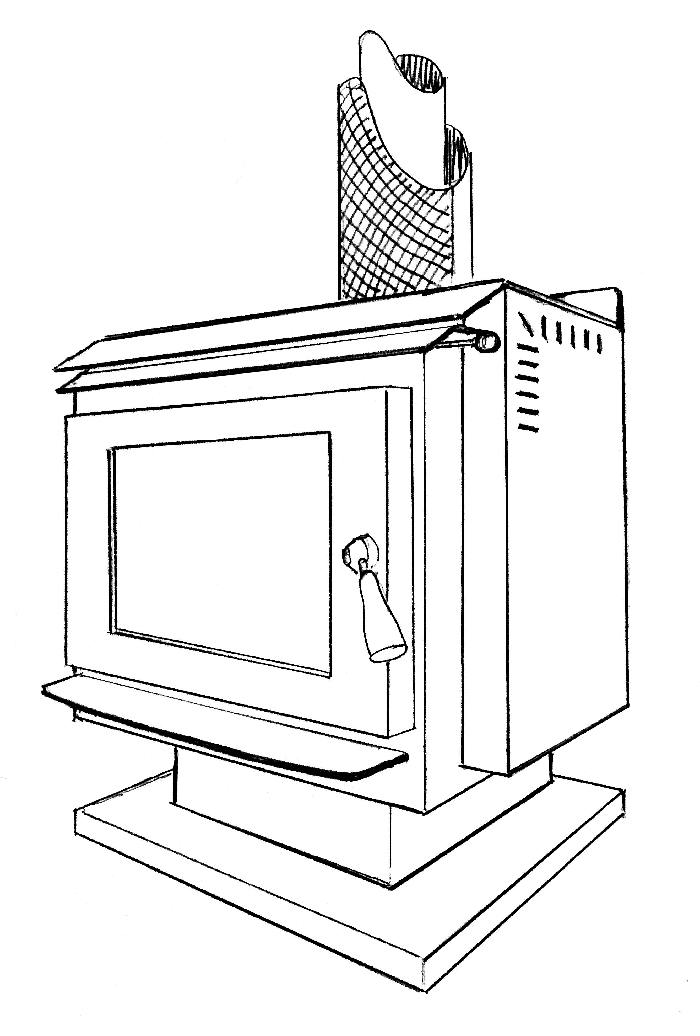

IMPORTANT - Installation and operation of this appliance must be carried out strictly
in accordance with the instructions contained here-in.

Some local authorities may require a permit for
the installation of your heater. We advise you
to check and arrange if so required.

IT IS STRONGLY RECOMMENDED THAT
YOU USE A QUALIFIED PERSON TO CARRY
OUT THE INSTALLATION.

This appliance complies with:
AS/NZS 4012/4013 : 1999 (Emissions) Report No: HCMG/12/011
AS/NZS 2918 : 2001 (Thermal Clearances) Report No: HCMG/12/013

Firefox Industries Pty. Ltd.,
ABN 95 074 490 654
4/15 Stud Road, Bayswater Vic AUS. 3153.
Phone: (03) 97209055 Fax: (03) 97209255
www.Firefox.com.au
INSTALLATION & OPERATING INSTRUCTIONS
Model: SCH 320

HEARTH (FLOOR PROTECTOR) REQUIREMENTS (Fig. 1)
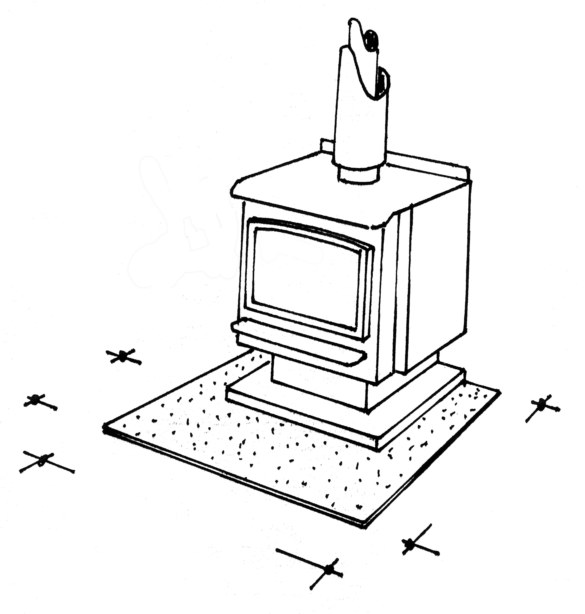

A floor protector of fibre cement sheet or other suitable non-combustible material must be placed beneath the base of the heater. The floor protector must be a minimum 910mm wide x 790mm deep and 12mm thick. The floor protector must be placed so that its leading edge is a minimum of 300mm forward of the heater base. (See Fig. 1).

300

790
910
Fig. 1

CLEARANCES TO COMBUSTIBLES FROM HEATER
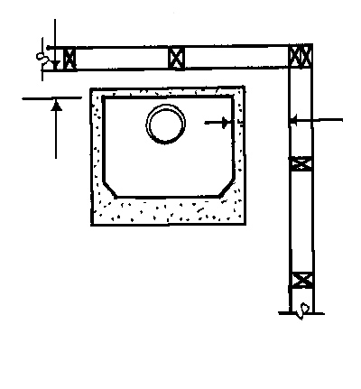
Fig. 2
When installed in position A (Parallel to a rear and side wall) maintain a minimum clearance to combustibles of 190mm from the rear wall and 400mm from the side wall from the heater.

When installed in position B (on a 45 degree angle to both side walls) maintain a minimum clearance of 200mm measured from the rear most corners of the heater.

Position A
190

400

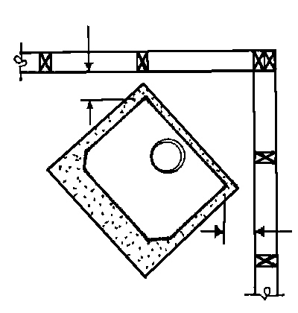

INSTALLATION & OPERATING INSTRUCTIONS
Position B
Page 1
200
200
Model: SCH 320

WARRANTY

Provided that the heater has been installed and operated as prescribed in the instructions, Firefox Industries Pty. Ltd. warrants the following against defects in workmanship and/or materials, as follows, from the date of purchase.

- The firebox for 10 years.
- All other components including (but not limited to) glass, firebricks, baffle, fan, fixtures and fittings for 12 months.

This Warranty shall not apply:

- If, in the opinion of Firefox Industries Pty Ltd, the heater or any of its components have been damaged due to defective installation, improper maintenance or repair, subjected to neglect, impact, misuse, excessive use, abuse, alterations or modifications.
- The heater has been purchased from an entity which has not been authorized by
Firefox Industries Pty Ltd.
- To owners other than the original purchaser.
- Parts replaced under warranty shall only be warranted for the balance of the original warranty period.
- At the discretion of Firefox Industries Pty Ltd, the cost of collection and delivery of the heater or any components that may require service or repair under warranty by an authorized Firefox service provider, shall be paid by the entity making the claim under the Warranty.

Please retain original invoice and receipt as proof of purchase shall be required prior to any Warranty claim being authorized. To validate your warranty please complete and return the Warranty Registration Card that has been provided. Warranty enquiries must be directed to Firefox Industries on (03) 97209055.

Date of Purchase: …………………………………………………………………….

Purchased From: ………..…………………………………………............................

………………………………………………………………………………………...

Model: ………………………………. Serial Number: ……………………………..

Page 6
INSTALLATION & OPERATING INSTRUCTIONS
Model: SCH 320

NORMAL OPERATING

- Always use dry hard split wood as fuel
- Do not burn chemically treated timbers or plastics as they may have a detrimental effect on your heater.
- Never operate your heater with the door open except on initially lighting.
- After periodic clean out of ash build up from the firebox ALWAYS leave about a 20mm thick layer spread across the bottom. This will act as an insulator and prolong the life of the firebox base.
- For best results ‘load’ your wood straight into the firebox pointing front to back not side to side.
- Always set the air slide on high when re-loading and run for about 15-20 minutes, or until the wood is well alight, before turning down.
- Always check that the firebrick tiles are in place, not cracked and in a serviceable condition. Never run the heater without the tiles in place as it can cause structural damage to your heater. Doing so will avoid the warranty.
- No matter how you run your heater some wood species will result in large amounts of ash, while others will give very little. Bark will give excessive ash. Try not to use it. Use the wood which is most convenient to you as long as it is dry.

FLUE CLEANING

It is recommended that the flue is cleaned at least once every season. The cleaner the flue the less chance of creosote build up. Failure to do so could result in a flue fire occurring which could result in property damage and/or personal injury. We recommend that you use a qualified person to perform this function.

FAN

If your heater is fitted with a fan it is recommended that the fan is operated on high fire. The fan should be periodically cleaned and free of lint and dust build up. Make sure electrical power source is disconnected prior to performing this function.

INSTALLATION & OPERATING INSTRUCTIONS
Page 5
Model: SCH 320

FLUE REQUIREMENTS & CLEARANCES TO COMBUSTIBLES
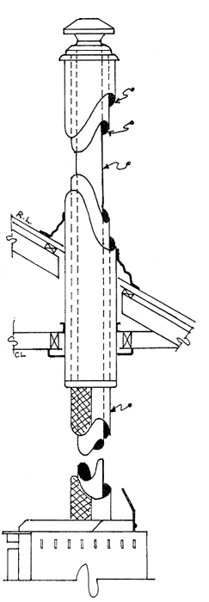
A triple skin flue kit approved to Australian Standards AS/NZS 2918 for combustion heaters must be used.

The flue kit must incorporate a Stainless Steel (active) flue of 152mm (6”) diameter in conjunction with:

- An Inner Galvanised Casing

- An Outer Galvanised Casing

- A decorative flue casing which is unperforated for 180° of its circumference can be used around the 6” Active Flue from the top of the heater.
(See Fig. 3).

OUTER GALV. CASING
180’
UN-PERFORATED SECTION OF DECORATIVE CASING
INNER GALV. CASING

INNER STAINLESS STEEL ACTIVE FLUE

Fig. 3

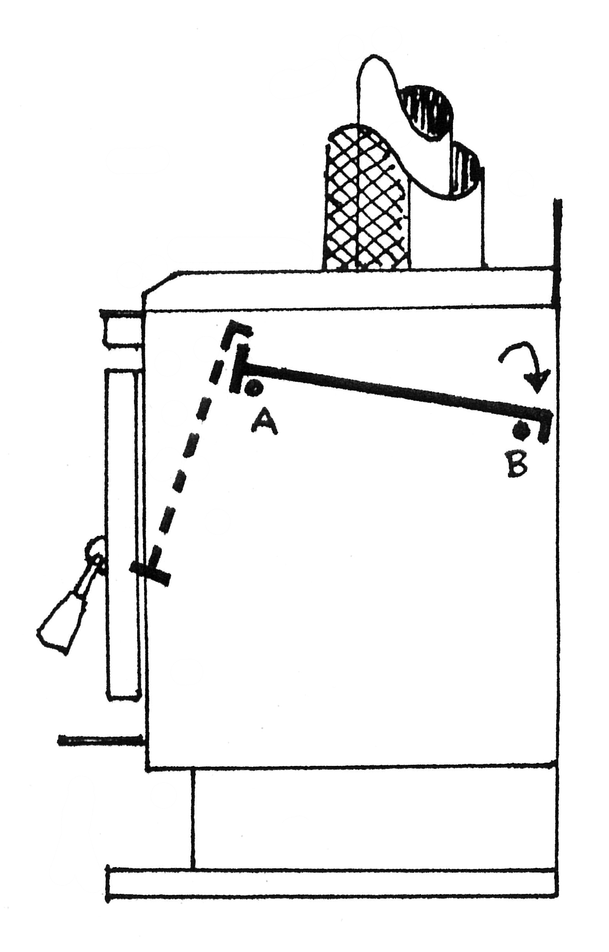
FITTING THE BAFFLE PLATE (Fig. 4)

- Lift the front end of the baffle plate (‘L’ section) up and over pin A and slide towards rear of the heater over pin B.
- When the baffle plate is resting on pins A and B the ‘L’ section should be at the rear of the firebox and the ‘T’ section should be at the front.
- The baffle plate should be hard up against the rear of the heater.

Fig. 4
Page 2
INSTALLATION & OPERATING INSTRUCTIONS
Model: SCH 320

PLACEMENT OF FIREBRICK TILES (Fig. 5)
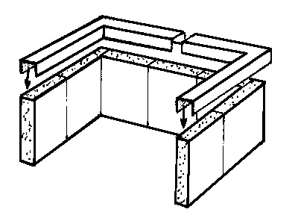
Seven and a half Firebrick tiles (2 for each side and 3 and a half for the back) and 2 retaining angle brackets are provided with the heater to line the inside walls of the firebox. Place 2 tiles along one side wall of the heater and one tile along the back wall. Place retaining bracket (‘U’ section down) over top edge of tile to secure in position. Repeat process on other side and place middle tile along the back. Ensure retaining brackets are sitting flat and secure in position over the tile edges.

Fig. 5

FINAL CHECKS PRIOR TO USE
- Flue is correctly fitted.
- Baffle Plate is properly located.
- Firebrick tiles are properly located.
- Fan cord (if a fan is fitted) is not resting against heater, plugged in and not damaged. Check door seals correctly.

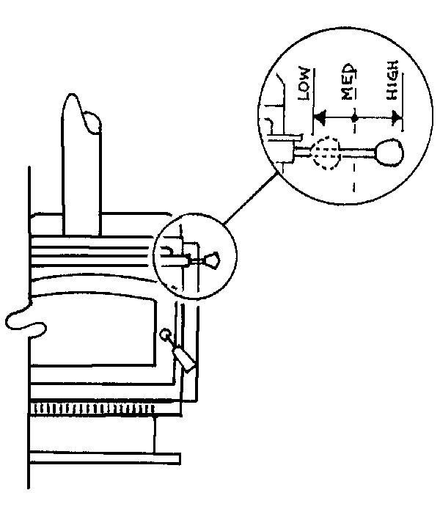

AIR CONTROL OPERATION (Fig. 6)
The air slide control knob is located on the top right hand side of your heater. A high setting supplies more air into the fire hence a hotter and quicker burn rate. A low setting supplies less air into the fire hence a cooler and slower burn rate. When first lighting your fire always start on the high setting.

INSTALLATION & OPERATING INSTRUCTIONS
Fig. 6
Page 3
Model: SCH 320

STARTING YOUR FIRE

- Place a few firelighters or crumpled newspaper in the firebox.
- Place a large amount of thin dry kindling in a criss cross fashion on top. Make sure there are air gaps between the kindling sticks of about 20mm.
- Ignite the firelighters or paper.
- Set the air control on high and leave the door open about 25mm.
- When the kindling is well alight, place about 4 small dry lengths of wood about 50mm thick on top of the burning kindling.
- Once the wood is alight close the door. When the wood is well alight, usually after about 15 – 20 minutes, set the air control to medium.

IMPORTANT

Do not ‘overfire’ your heater on the first burn. Use only about 4 small dry lengths of wood when re loading the fire for at least the first 2 or 3 fires on medium air setting. This will assist in curing paint finishes correctly. Your first fire may also cause some smoke to be emitted from the surfaces of the firebox. This is normal and will soon disappear. It is only the paint curing process and residue oils in the steel from the manufacturing process.

CARE OF GLASS WINDOW AND EXTERNAL SURFACES

- By burning good dry wood you will have very little discolouration on your glass in normal burning cycles.
- Make sure the wood is not resting or leaning up against the glass as this will cause sticky film spots to appear.
- A dark sticky film (creosote) build up on the glass is generally caused by burning wet or green wood on a low air setting, so always burn dry hard wood and periodically on high fire setting for cleanest results.
- Should cleaning the glass be required a wipe with a warm damp cloth will often be sufficient. For more stubborn stains a commercial cleaning product like Stove Bright Glass Cleaner or Johnsons Foam Clean may be required. Do not use commercial solvents or cleaners on the exterior finishes of the firebox. Wipe with a damp soft cloth only. Of course, make sure the fire is completely extinguished and the heater has cooled down before attempting this.
- The external surfaces of the Firefox heater can reach extreme temperatures. Whilst
the unit is finished in high temperature resistant paint, over firing may cause some deterioration of the paint surface. Should this occur, we recommend touching up with ‘Stove Bright’ Satin Black Paint.

